**Information about AJ Psychology Animal Assisted Therapy at Winhaven**

**Psychological Animal Assisted Therapy at Winhaven includes a combination of experiences and activities with animals. It can include developing emotional regulation strategies, problem solving strategies, relationship skills, communication skills, as well as talking about what those experiences mean to you.**

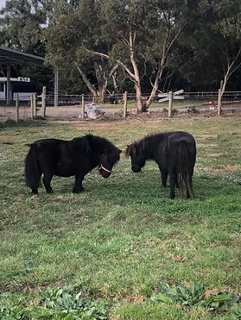**Animal assisted therapy**

Humans have been connected with animals since before recorded history, as is evidenced by cave paintings from around the world. The first active research into animal assisted therapy began in the 1900s with Dr Sigmund Freud noting that individuals did better in therapy sessions when his pet dog was present. In the 1960s research involving animal therapy increased. Today, the medical and mental health world accepts animal assisted therapy as a valid field, it is widely used for many physical, mental and emotional disorders: depression, anxiety, complex trauma, post-traumatic stress, grief, head injuries, attention deficit hyperactivity disorder and chronic diseases such as Alzheimer's. Lots of research also reports it being helpful for Autistic people.

Animal assisted therapy builds on a concept called the human-animal bond, which describes people's desire to interact with and relate to animals. For many people, by interacting with a friendly animal, they can form a bond with them. This bond can produce a calming state in the person allowing for therapeutic work to be undertaken. This type of therapy can be a fun and engaging way to approach therapy, as interacting with animals can be a more appealing and less intimidating way to engage in therapy than traditional talk therapy alone.

Animal assisted therapy is not a standalone treatment, it is a complementary approach to traditional therapy methods. It is designed to promote improvement in human physical, social, emotional, and/or cognitive function. Animal assisted therapy is a goal-oriented, planned, structured, and documented therapeutic intervention directed by trained mental health professionals, such as licensed psychologists or counsellors, who work with an animal to achieve specific therapeutic goals for the client. The therapy can take many forms, based on the professional’s clinical background, the client, the animal and the treatment plan. There is no standardized approach to animal assisted therapy. Not all animal assisted therapy practices work the

same or practice from the same therapeutic models, so it is important to ask each professional what their qualifications are and what model/s underpin their practice.

For more information about the differences of animal assisted therapy, animal assisted education / learning, and animal assisted activities please see:

<https://leadthewayinstitute.com.au/faqs/>

<https://www.insighttherapiesvic.com.au/difference-between-animal-assisted-therapy-and-animal-assisted-education/>

**Why work with animals?**

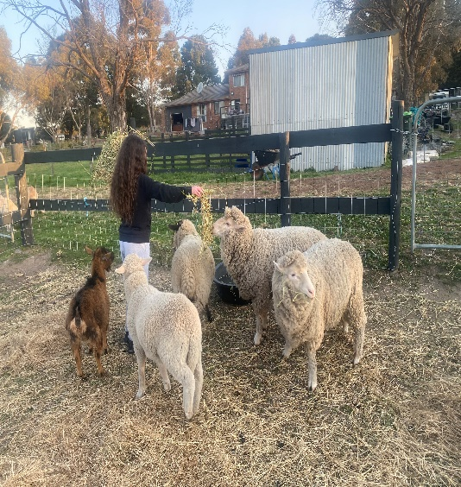

Animal assisted therapy can be helpful for people who have difficulty connecting with others or who struggle with social skills, as animals can provide a non-judgemental and unconditional source of support and help build trust and rapport between the therapist and client.

Animal assisted therapy has shown to help individuals rebuild a sense of safety and security, restore trust in others, and process difficult emotions associated with trauma. The presence of animals can also help reduce anxiety and hypervigilance often experienced by trauma survivors.

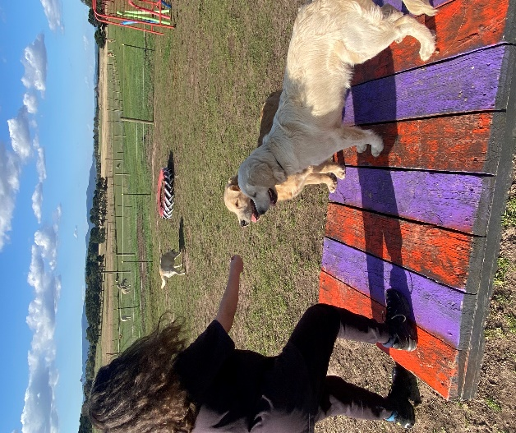Animals are sensitive beings and are interested in relationships, providing and presenting opportunities for feedback and to learn about yourself.  Animals are both social and some (horses) are prey animals, and as a result they have an ability to read our non-verbal communication.  This means they pick up on messages we send even if we are not always conscious we are sending them and they respond to us, providing feedback and the opportunity to work on ourselves.  Animals are in the moment and can be part of this relationship without biases (our past, education, gender, race, or other labels we apply to ourselves and each other), providing valuable insight about ourselves.

**There have been many benefits found when working with animals to assist therapy:**

**Physiological effects:**

* Decreased heart rate and blood pressure
* 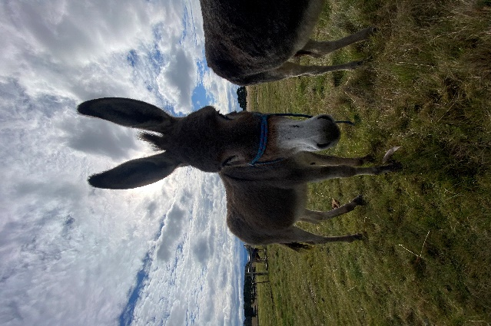Improved cardiovascular health, improved blood flow
* Released serotonin, prolactin, endorphins and oxytocin (hormones that generate a relaxation, stress reducing response and elevates mood)
* Slower breathing rate (assists with regulation)
* Boosts the immune system (increase in salivatory immunoglobulin A) when interacting and patting welcoming animals
* Released oxytocin which impacts the immune system, increases the pain threshold and diminishes overall physical pain
* Lower baseline levels of the stress hormone cortisol
* Promotes well-being

**Engagement and building rapport:**

* Animals can ‘break the ice’ between therapists and clients
* 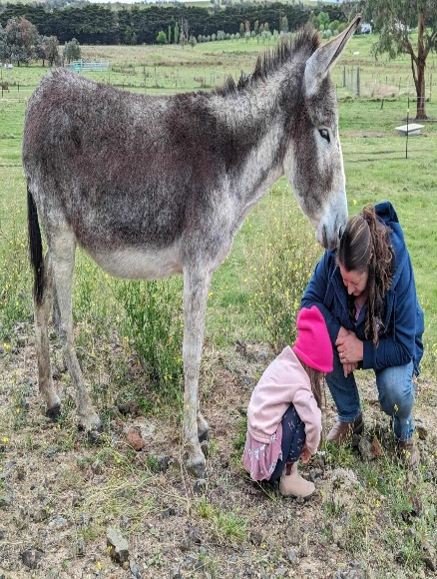Animals are helpful social facilitators and can help connection to humans
* Animals assist to enhance trust and facilitate feelings of safety
* Animals can provide comfort and a distraction as therapy can be challenging at times
* Animals can provide a safe non-judgmental space to assist with finding emotional support
* They assist to build rapport in the therapeutic relationship, and help improve communication and engagement with therapists
* Autistic children reported they felt a deeper bond with animals and felt that they were then better able to relate to humans
* Animals can serve as excellent conversation starter for parents and guardians looking to connect with their children and adolescents

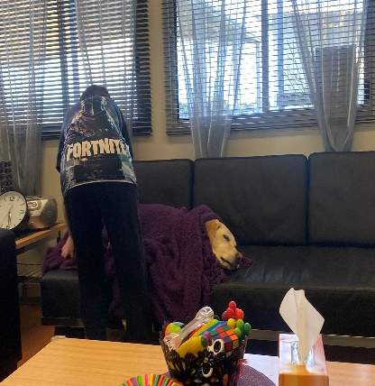

**Developing empathy and nurturing:**

* Animals can help to elicit positive emotions and warmth (when people experienced emotional numbing)
* Animals provide comfort, providing an opportunity for reciprocal action
* Allow a conversation about the importance of having empathy for ourselves and nurturing ourselves

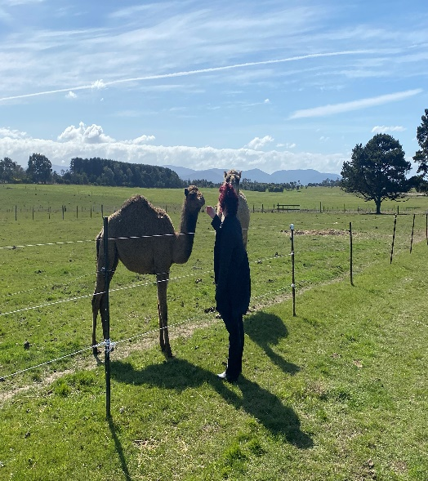

**Increased motivation:**

* To attend therapy sessions
* To engage in therapy sessions
* Reduced resistance to therapy
* Reduced dropout rates

**Decreased difficult behaviours while engaged in therapy:**

* Reduced aggression and agitation
* Reduced outbursts
* Reduced irritability
* Promoted social behaviour in people
* 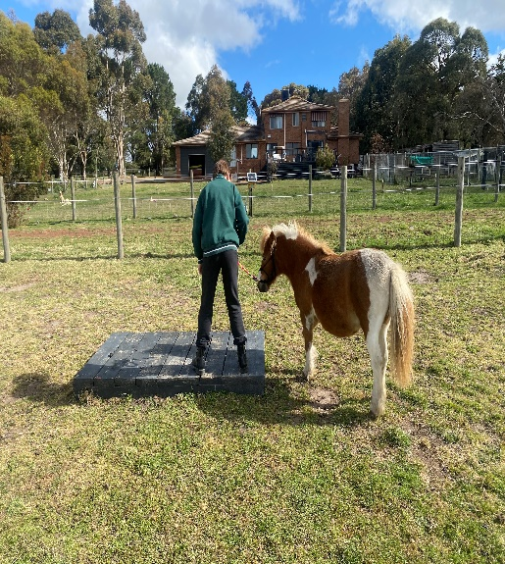Animals can foster a sense of calmness and promote cooperative behaviour

**Enhanced developmental maturity and responsibility**

* Animals can enhance a persons’ sense of control over their lives and environment – animals respond to their name being called and can perform simple tricks when instructed which can reinforce people’s locus of control and feelings of mastery
* Bonding with animals and working with them can increase feelings of self-efficacy and improved self-esteem

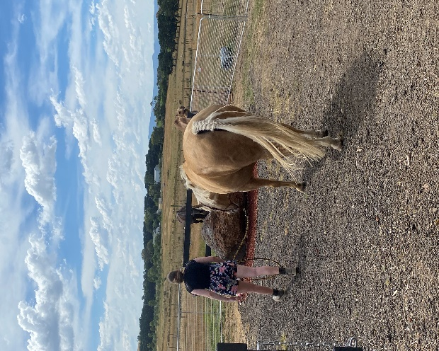**In the Mental Health field:**

* Studies have shown that interaction with animals causes biochemical changes in the patient's brain and release neurotransmitters that improve mood and cause relaxation and suppression of anxiety
* Reduction in depressive symptoms
* Increased attention skills
* Reduced loneliness through the emotional connection with animals
* Reduction of post-traumatic stress disorder symptoms
* Reduced the amount of medications some people need

​

**Skills improvement:**

* 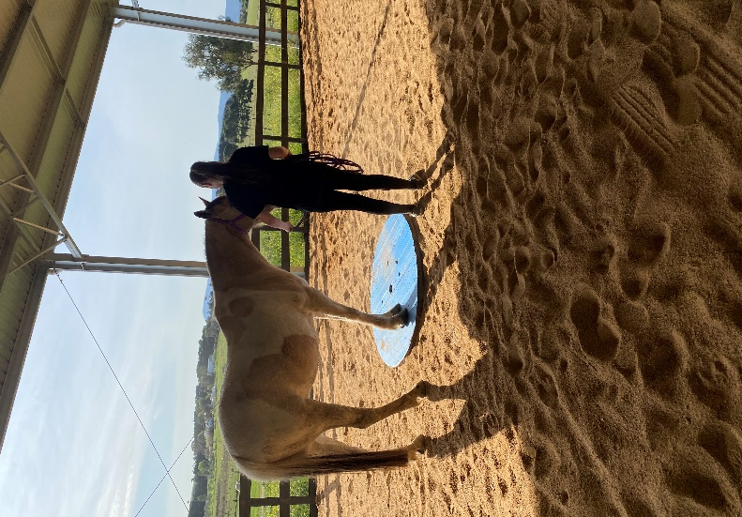Increased language skills (animals can assist spontaneous communication in situations where people might otherwise choose not to communicate)
* Autistic children engaged in significantly greater use of language as well as social interaction when their therapy sessions incorporated animals compared to standard therapy sessions without animals
* Increased social skills (relationship, friendship, reading body language, communication, assertiveness, problem solving, conflict resolution)
* In developing strategies to manage strong emotions (e.g. anxiety and anger)
* Improved leadership skills
* Improved strategies to manage grief and loss

***Animals provide opportunities for clients to practice and develop skills.***

**Are there risks with animal assisted therapy**

Any time animals and humans interact, there are risks:

* Animals can have germs that can make vulnerable people sick
* People might have allergies to animals
* Animals can be unpredictable, can move quickly and could accidently hurt someone by standing on them or knocking them over
* Animals could get scared and bite someone

While you cannot eliminate these risks completely, in reality, the training these animals receive, and the skill of the therapist make these small risks. Policy and procedures around animal vaccinations, worming, sanitation and safety can also reduce these risks. The benefits of improved healing and mental health far outweigh these small risks.

**What is Psychological Animal Assisted Therapy at Winhaven**

At AJ Psychology / Winhaven Animal Assisted Therapy sessions are conducted or overseen by a Clinical Psychologist, with training in Equine Assisted Psychotherapy and Canine Assisted Therapy.

Psychological Animal Assisted Therapy is an experiential form of therapy where animals can be involved in the sessions.  “Experiential” means that you may be involved in hands-on experiences with the animals designed to reflect things going on in your life.  It is about providing you the opportunity to experience, explore, problem-solve, discover, be creative,

gain insight and experience practical applications of what you are learning in the moment.  The process is about “doing” along with “talking”.

**What therapeutic models underpin the animal assisted therapy work at Winhaven**

At Winhaven we utilise several therapeutic models to inform our work:

* Person Centered Therapy
* Social Thinking Methodology
* Cognitive Behavioural Therapy
* Behavioural Therapy
* Gestalt Therapy
* Solution Focused Therapy
* Acceptance and Commitment Therapy
* Family Systems Therapy

These therapeutic models are explored through explicit teaching of knowledge and skills (psychoeducation & skills training) and in the moment (experiential learning) working with animals who provide a safe environment and relationship to practice these skills. The therapist can role model helpful ways of engagement and coping and animals provide immediate feedback to the client.

**What skills do we most commonly work on at Winhaven**

We will work with our clients to develop individual goals and a treatment plan for their therapy sessions. Below is a list of common goals for our work at Winhaven:

* Interoception awareness (to notice, recognise, and respond to our internal sensory system, both the physical and emotional states – key to helping regulate ourselves)
* External awareness (essential in keeping us safe)
* Co-regulation strategies
* Self-regulation (emotions, sensations, and thoughts)
* Problem solving strategies
* Relationship skills
* Social skills
* Communication skills
* Setting boundaries
* Assertiveness
* Conflict resolution
* Negotiation skills
* Impulse control
* Psychoeducation and treatment for mental health conditions
* Parent-child relationships
* Parenting support
* Grief and loss strategies

**

* We have a wide range of animals of different sizes, including ponies, horses, dogs, donkeys, camels, sheep, goats and guinea pigs.
* All our equine sessions are conducted “on the ground”, there is no riding of horses involved in the treatment process. The focus is on therapy, not to learn about horses or how to ride them.
* 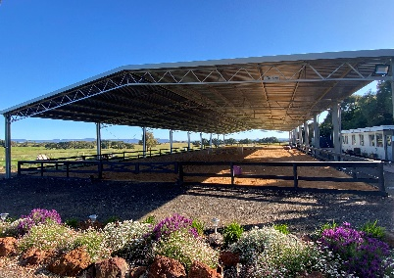Therapy animals can play different roles. This can range from being in the session to offer comfort, through to taking a more active role (grooming, walking, and engaging in experiments).
* This therapy takes place usually in an outdoor setting, on a rural property.  It is important to wear shoes that will protect your feet and appropriate clothing for the weather.  We do have a large undercover arena area and onsite parking.
* 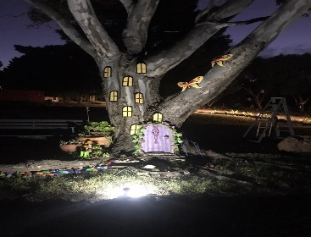We have office spaces to work in also.
* We have a kitchen, lounge room and toilet.  You are welcome to wait in the lounge room area before your session.
* Appointments will usually be 60 minutes in duration and as frequent as agreed upon.
* The first session will involve assessing your needs and working with you to create a treatment plan that outlines your therapy goals and answer any questions you have about the treatment.  It will also include a discussion about safety guidelines when working with animals.
* We will regularly review this plan with you to discuss progress or changes in the therapy goals.

**Our office / lounge / kitchen:**

***Check out the website for further information: winhaven.com.au***

**Animal Assisted Therapy References**

*This website reviews the research on animal assisted therapy and early interventions for autistic children:*

<https://www.ndis.gov.au/about-us/research-and-evaluation/early-interventions-and-high-volume-cohorts/evidence-review-early-interventions-children-autism/animal-assisted-interventions>

***Other relevant research articles:***

Ávila‐Álvarez, A., Alonso‐Bidegain, M., De‐Rosende‐Celeiro, I., Vizcaíno‐Cela, M., Larrañeta‐Alcalde, L., & Torres‐Tobío, G. (2020). Improving social participation of children with autism spectrum disorder: Pilot testing of an early animal‐assisted intervention in Spain. Health & Social Care in the Community, 28(4), 1220-1229. https://doi.org/10.1111/hsc.12955.

Becker, J.L., Rogers, E.C., & Burrows, B. (2017). Animal-assisted social skills training for children with autism spectrum disorders. Anthrozoös: A Multidisciplinary Journal of the Interactions of People and Animals, 30(2), 307-326. <https://doi.org/10.1080/08927936.2017.1311055>.

Bengtsson, A. & Carlsson, G. (2013). Outdoor environments at three nursing homes-qualitative interviews with residents and next of kin. Urban For. Urban Green. 12, 393–400.

Bengtsson, A. & Grahn, P. (2014). Outdoor environments in healthcare settings: A quality evaluation tool for use in designing healthcare gardens. Urban For. Urban Green. 13, 878–891

Borgi, M., Loliva, D., Cerino, S., Chiarotti, F., Venerosi, A., Bramini, M., Nonnis, E., Marcelli, M., Vinti, C., De Santis, C., Bisacco, F., Fagerlie, M., Frascarelli, M., & Cirulli, F. (2016). Effectiveness of a standardized equine-assisted therapy program for children with autism spectrum disorder. Journal of Autism and Developmental Disorders, 46(1), 1-9. https://doi.org/10.1007/s10803-015-2530-6.

Davis, T.N, Scalzo, R., Butler, E., Stauffer, M., Farah, Y.N., Perez, S., Mainor, K., Clark, C., Miller, S., Kobylecky, A., & Coviello, L. (2015). Animal assisted interventions for children with autism spectrum disorder: A systematic review. Education and Training in Autism and Developmental Disabilities, 50(3), 316-329.

Delta Institute Best Practice Guidelines. <https://9ae36e61-4b22-4230-bb95-f39083f7936e.filesusr.com/ugd/78eed2_40866d1ffc634bb997c914f82d4b4b14.pdf>

Furst, G. (2016). Helping war veterans with posttraumatic stress disorder: incarcerated individual’s role in therapeutic animal programs. Journal of Psychosocial Nursing and Mental Health Services. May 1;54(5):49-57. doi: 10.3928/02793695-20160420-07

Gibson, M., Dell, C.A., Chalmers, D., Rath, G., & Mela, M. (2023). Unleashing compassionate care: canine-assisted intervention as a promising harm reduction approach to prisonization in Canada and its relevance to forensic psychiatry. Frontier Psychiatry. Aug 3;14:1219096. doi: 10.3389/fpsyt.2023.1219096.

Guillen Guzmán, E., Sastre Rodríguez, L., Santamarina-Perez, P., Hermida Barros, L., García Giralt, M., Domenec Elizalde, E., Ristol Ubach, F., Romero Gonzalez, M., Pastor Yuste, Y., Diaz Téllez, C., Romero Cela, S., Real Gisbert, L., Salmeron Medina, M., Ballesteros-Urpi, A., Morer Liñan, A. (2022). The benefits of dog-assisted therapy as complementary treatment in children’s mental health day hospital. Animals. Oct 19;12(20):2841. doi: 10.3390/ani12202841.

Hoagwood, K.E., Acir, M., Morrissey, M., & Peth-Pierce, R. (2016). Animal assisted therapies for youth with or at risk of mental health problems: a systematic review. Applied Developmental Science. doi:[10.1080/10888691.2015.1134267](http://dx.doi.org/10.1080/10888691.2015.1134267)

Hediger, K., Wagner, J., Kunzi, P., Haefeli, A., Theis, F., Grob, C., Pauli, E., & Gerger, H. (2021). Effectiveness of animal assisted interventions for children and adults with post-traumatic stress disorder symptoms: a systematic review and meta-analysis. European Journal of Psychotraumatology. 12:1879713.

Hill, J., Ziviani, J., Driscoll, C., & Cawdell-Smith, J. (2019). Can canine-assisted interventions affect the social behaviours of children on the autism spectrum? A systematic review. Review Journal of Autism and Developmental Disorders, 6, 13-25. https://doi.org/10.1007/s40489-018-0151-7.

Hume, K., Steinbrenner, J.R., Odom, S.L., Morin, K.L., Nowell, S.W., Tomaszewski, B., Szendrey, S., McIntyre, N.S., Yücesoy-Özkan, S., & Savage, M.N. (2021). Evidence-based practices for children, youth, and young adults with autism: Third generation review. Journal of Autism and Developmental Disorders, 51(11), 4013-4032. https://doi.org/10.1007/s10803-020-04844-2.

Joschko, L., Palsdottir, A.M., Grahn, P., & Hinse, M. (2023). Nature-based therapy in individuals with mental health disorders, with a focus on mental well-being and connectedness to nature – a pilot study. Internation Journal of Environmental Research and Public Health. 20:2167. Doi:10.3390/ijerph20032167

Kamioka, H., Okada, S., Tsutani, K., Park, H., Okuizumi, H., Handa, S., Oshio, T., Park, S-J., Kitayuguchi, J., Abe, T., Honda, T., & Mutoh, Y. (2014). Effectiveness of animal-assisted therapy: A systematic review of randomized controlled trials. Complementary Therapies in Medicine, 22(2), 371-390. https://doi.org/10.1016/j.ctim.2013.12.016.

Maber-Aleksandrowicz, S., Avent, C., & Hassiotis, A. (2016). A systematic review of animal-assisted therapy on psychosocial outcomes in people with intellectual disability. Research in Developmental Disabilities, 49-50, 322-338. https://doi.org/10.1016/j.ridd.2015.12.005.

National Autism Center (NAC). (2015). Results of the national standards project, phase 2. NAC. Retrieved 6 May 2022 from https://www.nationalautismcenter.org/national-standards-project/results-reports/.

National Institute for Health and Care Excellence (NICE). (2013). Autism spectrum disorder in under 19s: Support and management. NICE. Retrieved 6 May 2022 from https://www.nice.org.uk/guidance/CG170/chapter/1-Recommendations.

O’Haire, M.E. (2017). Research on animal-assisted intervention and autism spectrum disorder, 2012–2015. Applied Developmental Science, 21(3), 200-216. https://doi.org/10.1080/10888691.2016.1243988.

O’Haire, M.E. (2013). Animal-assisted intervention for autism spectrum disorder: A systematic literature review. Journal of Autism and Developmental Disorders, 43(7), 1606-1622. https://doi.org/10.1007/s10803-012-1707-5.

O’Haire, M.E., McKenzie, S.J., McCune, S., & Slaughter, V. (2014). Effects of classroom animal-assisted activities on social functioning in children with autism spectrum disorder. The Journal of Alternative and Complementary Medicine, 20(3), 162-168. <https://doi.org/10.1089/acm.2013.0165>.

Pálsdóttir, A.M.; Stigsdotter, U.K.; Persson, D.; Thorpert, P.; Grahn, P. (2018). The qualities of natural environments that support the rehabilitation process of individuals with stress-related mental disorder in nature-based rehabilitation. Urban For. Urban Green. 29, 312–321.

Pandey, R.P., Himanshu, Gunjan, Mukherjee, R., & Ghang, C.M. (2024). The role of animal assisted therapy in enhancing patients’ well-being: systematic study of the qualitative and quantitative evidence. JMIRx Med 2024;5:e51787 doi:10.2196/51781

Prior, M., & Roberts, J. (2012). Early intervention for children with autism spectrum disorders: Guidelines for good practice. Australian Government Department of Social Services. Retrieved 6 May 2022 from https://www.dss.gov.au/our-responsibilities/disability-and-carers/program-services/for-people-with-disability/early-intervention-for-children-with-autism-spectrum-disorders-guidelines-for-good-practice-2012.

Prior, M., Roberts, J.M.A., Rodger, S., Williams, K., Dodd, S., Ridley, G., & Sutherland, R. (2011). A review of the research to identify the most effective models of practice in early intervention for children with autism spectrum disorders. Australian Government Department of Families, Housing, Community Services and Indigenous Affairs. Retrieved 6 May 2022 from <https://www.dss.gov.au/sites/default/files/documents/10_2014/review_of_the_research_report_2011_0.pdf>.

Sandbank, M., Bottema-Beutel, K., Crowley, S., Cassidy, M., Dunham, K., Feldman, J. I., Woynaroski, T. G. (2020a). Project AIM: Autism intervention meta-analysis for studies of young children. *Psychological Bulletin, 146*(1), 1-29.

Schuck, S.E., Johnson, H.L., Abdullah, M.M., Stehli, A., Fine, A.H., & Lakes, K.D. (2018). The role of animal assisted intervention on improving self esteem in children with attention deficit hyperactivity disorder. Frontier Pediatric. 6:300 doi: 10.3389/fped.2018.00300

Smith, B.P., & Dale, A.A. (2016). Integrating animals in the classroom: The attitudes and experiences of Australian school teachers toward animal-assisted interventions for children with autism spectrum disorder. Pet Behaviour Science, 1, 13-22. http://doi.org/10.21071/pbs.v0i1.3994.

Trzmiel, T., Purandare, B., Michalak, M., Zasadzka, E., & Pawlaczyk, M. (2019). Equine assisted activities and therapies in children with autism spectrum disorder: A systematic review and a meta-analysis. *Complementary Therapies in Medicine*, 42, 104-113. doi:10.1016/j.ctim.2018.11.004

Whitehouse, A., Varcin, K., Waddington, H., Sulek, R., Bent, C., Ashburner, J., Eapen, V., Goodall, E., Hudry, K., Roberts, J., Silove, N., Trembath, D. (2020). Interventions for children on the autism spectrum: A synthesis of research evidence. Autism CRC, Brisbane.

Wong, C., Odom, S.L., Hume, K.A., Cox, A.W., Fettig, A., Kucharczyk, S., Brock, M.E., Plavnick, J.B., Fleury, V.P., & Schultz, T.R. (2015). Evidence-based practices for children, youth, and young adults with autism spectrum disorder: A comprehensive review. Journal of Autism and Developmental Disorders, 45(7), 1951-1966. https://doi.org/10.1007/s10803-014-2351-z.

Yap, E., Scheinberg, A., & Williams, K. (2017). Attitudes to and beliefs about animal assisted therapy for children with disabilities. Complementary Therapies in Clinical Practice, 26, 47-52. https://doi.org/10.1016/j.ctcp.2016.11.009.

Yarborough, B.H., Owen-Smith, A.A., Stumbo, S.P., Yarborough, M.T., Perrin, N.A., & Green, C.A. (2017). An observational study of service dogs for veterans with posttraumatic stress disorder. Psychiatric Services. Jul 1;68(7):730-734. doi: 10.1176/appi.ps.201500383